Summary of Dynamic and

Condenser Mic Pros and Cons
Dynamic Mic Advantages | Condenser Mic Advantages
Rugged | More Sensitive
Lower Cost | Better Audio Quality
No Power Required | Can Be Extremely Small
Dynamic Mic Disadvantages | Condenser Mic Disadvantages
Lower Sensitivity and Power Output | Higher self-noise
Larger and Heavier | More Fragile
Slower Response Time | More Expensive
Not the Best Choice for Maximum Audio Quality | Prone to Weather Problems and RF Interference

Ribbon Mics
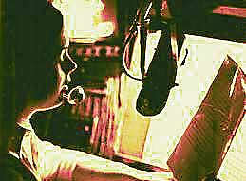
Except possibly for an announce booth (shown here), ribbon mics are seldom used in TV production.
Although they can impart a deep, resonant "coloring" to sound, they are fragile and highly sensitive to moving air. This precludes their use outside the studio and on most booms -- which covers most TV production applications. Ribbon mics were primary used in radio studios.

Boundary Effect Mics
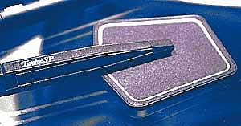
PZ (also called PZM) stands for sound pressuremicrophone, which comes under the heading of a boundary effect microphone. This mic relies entirely on reflected sound.
In specific situations, such as when placed on a tabletop, a PZ mic will provide a pickup that's superior to that of other types of mics.

Contact Mics
As the name suggests, contact mics pick up sound by being in direct physical contact with the sound source. These mics are generally mounted on musical instruments, such as the surface of an acoustic bass, the sounding board of a piano, or near the bridge of a violin.
Contact mics have the advantage of being able to eliminate interfering external sounds and not being influenced by sound reflections from nearby objects. Their flat sides distinguish them in appearance from small personal mics.

Directional Characteristics
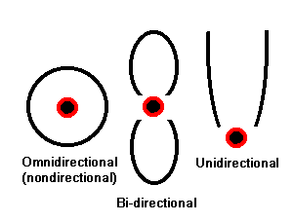
In an earlier module we talked about the angle of view of lenses -- the area that a lens "sees."
Microphones have a similar attribute: their directional characteristics, or, you might say, the angle of view that they "hear."
In microphones there are three basic directional categories:
- omnidirectional
- bidirectional
- unidirectional

Omnidirectional Mics
Omnidirectional mics (also called nondirectionalmics) are (more or less) equally sensitive to sounds coming from all directions.
One of their advantages is that they are less sensitive to breath popping in close mouth-to-mic use, such as ▲ the reporter doing an ENG report.
However, in general video production where the mic isn't hand-held it's almost always more desirable to use some form of directional mic. For one thing, this will reduce or eliminate unwanted sounds (behind-the-camera noise, ambient on-location noise, etc.) while maximizing sound coming from talent.

Bidirectional Mics
In a bidirectional sensitivity pattern (bipolar pattern) the mic is primarily responsive to sounds from two directions. Note drawing above.
Although commonly used in radio interviews for people sitting across from each other at a table, until the advent of stereo, bidirectional (also called figure eight) sensitivity patterns had limited use in television. We'll get into stereo and the need for this type of directional pattern in a later module.

Unidirectional Mics
The term unidirectional simply refers to a general classification of mics that are sensitive to sounds coming primarily from one direction.
There are four subdivisions in this category -- each being a bit more directional:
- cardioid
- supercardioid
- hypercardioid
- parabolic
Although these terms may sound as if they belong in a medical textbook, they simply refer to how narrow the mic's pickup pattern ("angle of view") is.

Cardioid
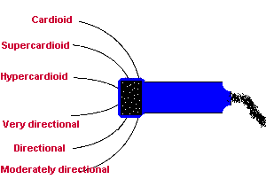
The cardioid (pronounced car-dee-oid) pattern is named after a sensitivity pattern that vaguely resembles a heart shape. (You will be able to see this later in a top view illustration.)
The drawing here is a highly simplified depiction of three directional patterns.
Mics using a cardioid pattern are sensitive to sounds over a wide range in front of the mic, but relatively insensitive to sounds coming from behind the mic.
Although this pattern might be useful for picking up a choir in a studio, the width of a cardioid pattern is too great for most TV applications. When placed two or more meters (7 or more feet) from a speaker, it tends to pick up unwanted, surrounding sound, including reverberation from walls.
When hand held, cardioid mics pick up less background noise than omnidirectional mics, but when used in this way they require thicker pop filters to reduce the pops from plosive sounds such as "Ps" and "Bs.
They also tend to exaggerate bass when held close to the mouth. (We'll have more about these issues when we talk about hand-held mics in the next module.)

Supercardioid
The supercardioid is even more directional than the cardioid sensitivity pattern.
Whereas the cardioid has about a 180-degree angle of acceptance, the supercardioid has about 140-degrees of coverage. When this type of mic is pointed toward a sound source, interfering (off-axis) sounds tend to be rejected.
This polar pattern is similar to that of our ears as we turn our head toward a sound we want to hear and try to ignore interfering sounds.

Hypercardioid and Lobar
Even more directional are the hypercardioid and lobar patterns with less than 140-degrees of coverage. Because off-axis sounds will be largely rejected, they have to be accurately pointed toward sound sources. Some highly directional shotgun mics (below) are included in the hypercardioid category.

Shotgun Mics
So called shotgun mics with their hypercardioid or narrower angles of acceptance represent one of the most widely used types of mics for on-location video work.
Since they are quite directional, they provide good pickup when used at a distance of 2 to 4 meters (7-13 feet) from the talent. Like other types of directional microphones, they tend to reject sound that would interfere with the on-camera talent.
Highly directional mics should not be used close to talent because they exaggerate bass. In addition to on-location settings, they are useful in stage and PA applications where amplified speakers are being used, because they can deliver higher audio levels before feedback starts.

The drawing below shows another way basic microphone sensitivity patterns (polar patterns) can be visualized. These drawings represent top views of the microphones and the light blue arrows represent the direction the mics are pointed. The magenta areas represent the areas of maximum sensitivity.

Parabolic Mics
Parabolic mics represent the most highly directional type of mic application. This category refers more to the application of the microphone rather than the directional pattern of the mic, itself.
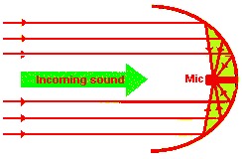
In fact, the mic used in the focus point (center) of the parabola can be any general cardioid or supercardioid mic.
The parabolic reflector can be from 30 cm to 1 meter (1 to 3 feet) in diameter.
Because of the parabolic shape of the reflector, all sound along a very narrow angle of acceptance will be directed into the microphone at the center.
Parabolic microphones can pick up sound at distances of more than 60 meters (200 or more feet). These mics are not practical for general field production work, but they are often used in sports.
For parabolic mics, or any type of directional mic used on location, the person controlling the mic should always be wearing a good set of padded earphones connected to the mic's output, especially if subjects are moving.
A slight error in aiming a highly directional mic can make a big difference in audio quality.

